Human Interface Analyze
Date | Version | Name | Comment
16/01/2008 | 0.1 | Ray Lin | Draft, Initial
17/01/2008 | 0.2 | Ray Lin | Draft, reference SL25 UI doc
17/03/2008 | 0.21 | Ray Lin | Add screen shoots of demo

Issue
Use bitmap or rendered by 2D API? Need more test on the evaluation board.

References
sl25 ui.doc
Operator menu.xml

UI characteristic of current system

LOGO | CREDIT
MENU
STATUS
INFO

spengler | Freevend
- Espreso
- Double espresso
- Cappuccino
- American coffee
- Espresso choc
- Chocolate
- Whipped chocolate
- Hot water
0. Flask
Make your choice
Machine 00 service@mass.nl

Keypad:

1 2 3
4 5 6
7 8 9
< 0 >
RETURN RESET START

Navigate with menu and simple keypad.
Only highlight when current menu item available

UI elements
Menu
1 – 9 to select the menu item, or <, >to navigate, then START to select

Popup windows
To show or modify attribute
1-9 to select option
<,> ,START to switch attribute, RETURN to cancel.

Scrolled window
To show information more than one page.
<,> to scroll

Text box
1-9 to input digit
<, > to increase or decrease number, like a spin control.
RETURN to enter the mode for inputting alphabet and other symbols, using <,> to switch.

Menu tree
0. Quickmenu
1. Client data
2. Machine
3. Pay functions
4. Test functions
5. Log
6. Miscellaneous
7. Reset automat
8. Test consumption
9. Enter Password *

0.Quickmenu
1 view turnover prod. Per.
2 view turnover cashbox
3 Machine at #2
4 Log
Client data

1.Client data
1. Prices
Price of A,B,C,D
2. Standby
1.show show standby time percent by weekday in graphic
2. Activation
1.No 2.Clock 3.Auto
3. Funct.off
1.NO 2.Clock
3. Choice panel
1. Choose mode
1.Indirect 2.Direct
2. Choice active
30 sec
3. Preference on card
1.No 2.Yes
4. Menu options
1. Repeat function NO YES
2. Fast choice NO YES
3. Menu choice Info ? //show menu
4. Block choices ? //show menu
5.Walking text No Yes
6.Suppress price No Yes?
7. Simultane dispense Not allowed Allowed
5. Free vend IR
Free vend IR No Yes
Prog. Jug IR No Yes
Prog. Free IR Nr= 1000031 send IR-code (F)
6. Opr.access Level 0-151

4. Clock functions
- Price
set Price A-D for specific week day and time
2. Standby mo-mo 0000-0000
Enter standby mode at specific time?
3.Funct. off mo-mo 0000-0000
Function off at specific time

5. Language 1.Nederlands 2 Deutsch
6. EVA / DTS
1. EVA Baud.
2. Reset pword are you sure
3. Ini are you sure

7. Miscellaneous
1.Key number 1001A
2.admin-types 1 EVA 2.BOS
9. Init are you sure

2.Machine
1. Components
2. Preparations
3. Recipes.
1. FB Coffee
1. Black
1. FB flake
Pick dosage step
1. Minimum. dosage
2. Standard dosage
3. Maximum dosage

2. Water

2. Creamer
3. Sugar
4. Complete (C)

2. Decafe
3. FB Mocca
4. FB Mocca decafe
5. FB Cappuccino
6. Other products

4. Programs
1. Air test brewer
2. Rinsing short
3. Purification
4. Fill Boiler

5. Durations
6. Assortment
7. Service mode
8. Miscellaneous
9. Test comp

3. Pay functions
1. Pay options
1. Country
2. Vend mode
1. Vend mode 1.singlevend 2.Multivend
2. Mandatory sale 1.Buy oblig. No 2.Buy oblig. Yes
3. Price mode
1.Freevend 2.Price-following 3.Price-holding
5. Enviroment 1.Closed 2.Open
3. Vend opt.
1. Vend seq. 1.Card first 2.Coins first
2. Reload set 1.No revalue 2.Direct revalue 3.Revalue at ret
3. Overpay take 1.Leave 2.Take in
4. Mixed payments 1.Allowed 2. not allowed
5. Vend 0 card 1.Do vend 0 2.No 0 vend
6. Bonus 1.Disabled 2.Enabled
7. Bonus-amount $.00
4. Card set
1.Enable CUG 1.Disable 2.Enable
2.Max credit $ 2474836.47
5. Coin set
1.Max credit $ 21474836.47
2.Overpay $ 21474836.47
2. Device set
1. Reader set
1. MdB text 1.Allow 2.Supress
2. Card language 1.Switch to 2.Ignore
3. Show credit 1.As required 2.Always
4. Price item swap 1.None 2.Price=>Item 3.Item=>Price
5. Reader port 1.Internal 2.MDB bus

2. Changer set
1. Empty width 0
2. National coins
1. Accept nat. coins 2.Block .nat.coins
3. Select disable
Ch01:0
…
Ch04:0
3. Acceptor set
1. Max coins count 255
2.Acc channels
Ch01:1
…Ch12:65535
3. Credit device test
1.Maintenance fncs no more present
2.Test fncs no more present
4. Init ?reset?

4. Test functions
1.Keyboardtest
2.LCD
1.LCD contrast 7000
2.LCD backlight high 4000
3.LCD backlight low 0000
4.LCD dim time 60 sec
5.Display test //display Character set

5. Log
1. Show
2. Clear Are you sure?

6. Miscellaneous
1. Software vers.
SL-mainLCD V4.13 Sep 17 2007 GUI SYSTEM V3.05
XA_Xrtxc v3.090
…
2. Date / Time
Time 10:07 mo
Date 07-01-2008
3. View turnover
1. Prod. Per.
Product 1 A //<>START
Amount= 0.00 Count= 0
2. Prod. cum.
…//as above
3. Audit Per.
Value=0.00 cashbox 0
4. Audit cum.
… //as above
5. Cashbox
Total=$ 0.00
6. Clear turnover are you sure?

4. Baudrate 1200 //<>
5. Tel. number service@mass.nl //ALL KEYPAD
6. Mach. Number
1.Mach.number 100 //<>
2.Format 2 digits //ALL KEY
8. Hardware Info
Dectected hardware Bus-adr sts //<>
RTC-PCF8593 I2C-a2 +
SLAVE I/O HOT 1 SI04-2 +
… Slave I/O CCD SI04-5 -

7. Reset automat

8. Test consumption //go to sale menu?

9. Enter Password *

About the current operation menu tree
Con.
Volume of miscellaneous functions, all enclose in operator menu, functions not well classified by operator role, it’s hard to locate a function in deep level menu structure.
Possible improvement:
Group functions by fine defined actor role, only shows authorized function, not just reveal them in gray; each role have its own menu.
Remove trivial functions; compress the levels of the menu tree
Provide task oriented functions, relieve operator from setting parameters individually.
Make parameter revelation more intuitive, e.g. let users choose it in predefined list with meaningful name rather than let them directly modify digit.
Add context help support.

For fast navigation, use menu based gui other than dialog based?
Customize menu by customer need.
Add self test function?

User type

OPERATOR – Customer or user who uses the beverage dispenser only for obtaining beverages under the conditions stipulated by the installer or operating company. He has no access to the inner part or programming of the machine.
SERVICE TECHNICIAN - Trained specialist who knows the risks of the machine and is familiar with the technology of the machine. Service technicians are trained and capable of installing, maintaining,repairing and programming the machine.

INSTALLER – Responsible for correct installation and maintenance of the machine.
Task:
Fill boiler (Machine / Program / Fill boiler);
The machine can be adjusted with the sub-menu “Calibration” by accurately weighing the actual
amount of dispensed ingredients, comparing this value with the value set in the program andchanging the setting, if required.

OPERATING COMPANY – Responsible for correct and regular filling and cleaning of the machine.
FILLING TECHNICIAN - Staff member tasked with filling and cleaning of the machine.
Task:
Machine -> Programs->1. Rinsing (short)

UI modes
User mode
Service/operator mode
Standby/functional off mode

UI Requirement

The business mode/Target market
The target market of SL15 is similar to SL25, Paul have prepare a document about the SL25 UI, Some contents here are directly reference from that document.

The SL15 must meet the need for two markets at the same.
- OCS(Office coffee service)
Services like cleaning, recharging are done by operator of service provider.
- End customer
The services are done by customers themselves

Life stage
The machine knows different life stages. Starting with assembly, machine software may show different content of test programs helpful by end test phase. Secondly installation stage will force machine to execute intro procedure where language, water filter and volumes are set. After intro procedure is executed in use stage becomes valid automatically.

User types
Customer
User, who uses the beverage dispenser only for obtaining beverages, only operates in user/vending mode.
Operator
Responsible for installation, maintaining and cleaning of the machine, for they may be end customers, the system should provide predefined functions to guide the operator step by step to complete these jobs.

SERVICE TECHNICIAN
Trained specialist who knows the risks of the machine and is familiar with the technology of the machine. Service technicians are capable to run tests function, and are authorized to see detail parameters of the machine.

Hardware/software restriction

Screen
Size: 95.04 x 53.856
Display resolution: 480x272
Pixel size 0.198 x 0.198

Touch pad
Resolution: 15 x 8

Processor:
ARM926EJ-S

VFP (Vector Floating Point )
None (AT91SAM9261-EK evaluation kit)
Possible to add VFP9 Vector Floating Point coprocessor ? Does CE support floating point unit?

Graphic acceleration:
None

Consideration

What is the authorized mechanic of current system?

Screen Layout horizontal or vertical



Vertical
Almost all Mobil use this mode
Good for menu operation and vertical scroll bar
Look weird in this width-height scale

Consideration for the touch pad’s resolution
From a perspective of a software developer, if we choose a pen as input option, it would be better if the touch pad’s resolution reach the level of pocket PC, which brings these favorites:
- Support WINCE GUI elements
- Support drag drop mode, which significant impact on scroll bar
- No limit on the locations of GUI elements
- Fewer limit on UI elements size. Possible to use mixed grid size.
Note:
For the stylus is not supported by the candidate touch pad, the meaningful highest touch resolution is that the human finger can reach.

The grid size
For the limitation in screen size, we face a tradeoff between the user’s experiment and the intent of displaying more information on screen.
The decreasing in grid size leads to slowdown of the user’s operation and increase the possibility of fault selection.
Without pen assistant grid size of 5x3 is the best for user experience, but brings greatly difficulty to UI design.

5 x 3
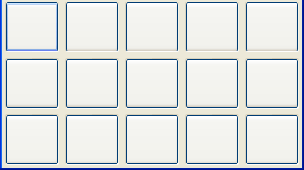
7 x 4

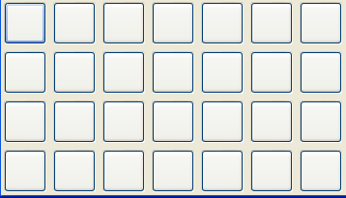
7 x 4

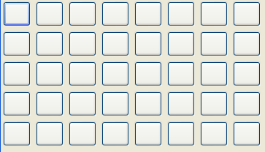
8 x 5

Use stylus/ pen to assist user input?
Maybe we can think about using 5 x 3 grid size in user mode, and 7x4 or 8x5 in user mode with the assistant of pen.
Note:
The candidate capacitive touch pad do not support pen.

Feature Request
Multilingual
Flexible to customize menu
Changeable style/skin?
Chinese characters?
Animation for advertising
Preferred:
Touch gestures(support by software, no special request to hardware)
transition effect

The interface principle
User/vend mode:
Keep interface Intuitive and simple, flat menu.
Wizard like style, instruct user step by step to complete the operation.
Use bitmap to enrich the interface’s appearance.
Fast navigating and operating

UI elements
Popup dialog (model)
Message box(warning, confirm…)
Date time select dialog
Button/bitmap button
Bitmap
Static text
Scroll window
To show info like log
Radio/toggle button
Progress bar
Show the progress of some operation, for example preparation.
Animation
Slider
Let user intuitively increase or decrease the value.
Auto Layout?

Sketch

User Home Screen
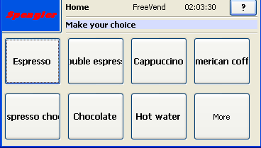
1
2
3
4
5

- Button to navigate to Home, also display the logo of the company.
- Title of current dialog
- Status bar
- Context help toggle button ,when the button is toggled, press on controls would not trigger any action but instead showing the help message on the message bar.
- Message bar to show tips.
To enrich the appearance of the interface, use bitmap button or list view like windows style:
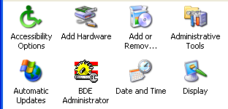

User Vend Screen
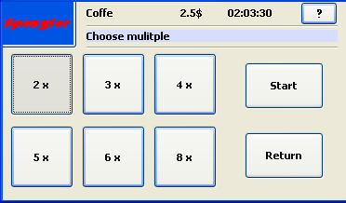
Use toggle button to select option

Screens of a demo
Home screen

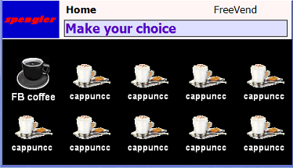

Option screen

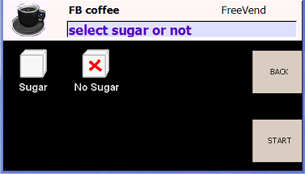

Prepare screen

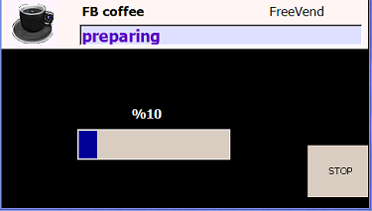

Operator menu

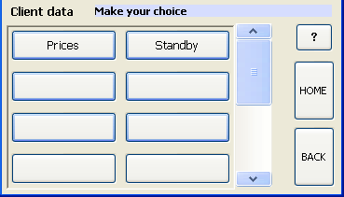

Property window
To show or modify option

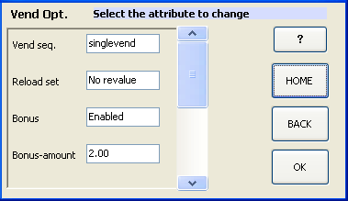
When kick an attribute, a popup choosing window or edit window will show.

Choosing window
Popup window to choose an option

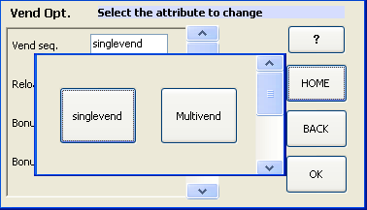

Text edit window
To edit text

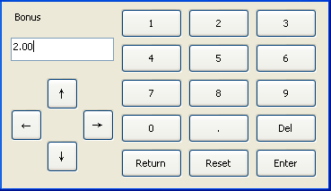
Next to do:
Define how to input alphabet or other special character.

Another proposal for Operator interface

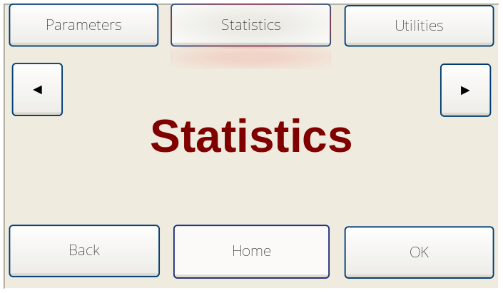

The top part is menu area, the center button is present the selected item
The centre area is to show detail information of the selected item, can be correlated bitmap.

To navigate the menu items, use ◄ ► buttons, or slide the finger upon the center part if gesture feature is supported.
To enter the function, touch a button on top or touch the OK button to enter current selected function.

In the leaf node
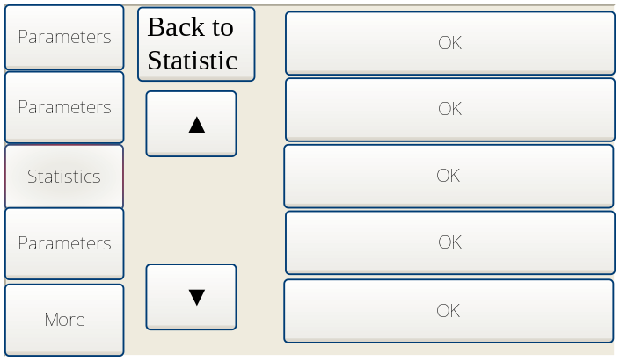

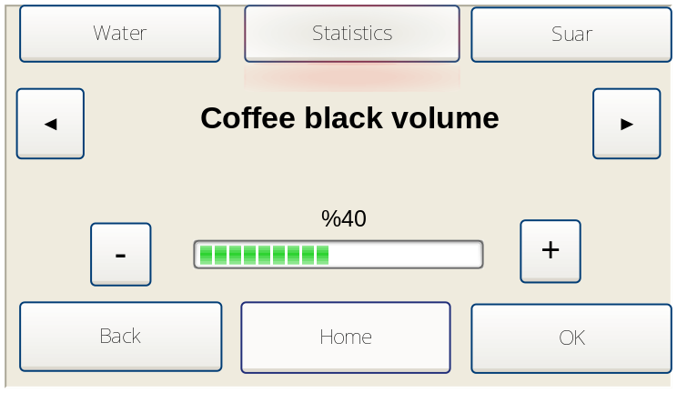

Date Time selection window

Some UI collections
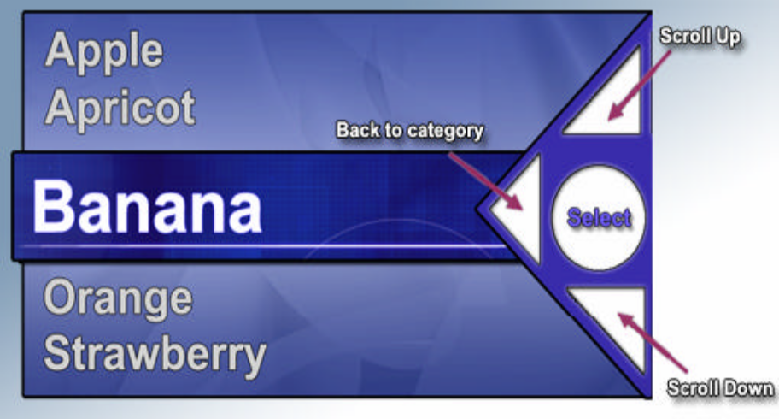
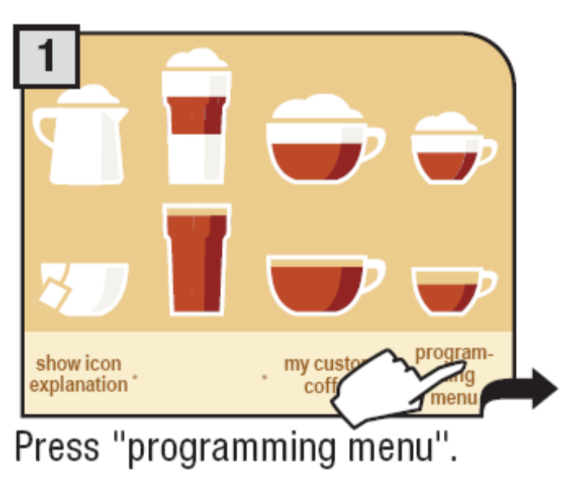
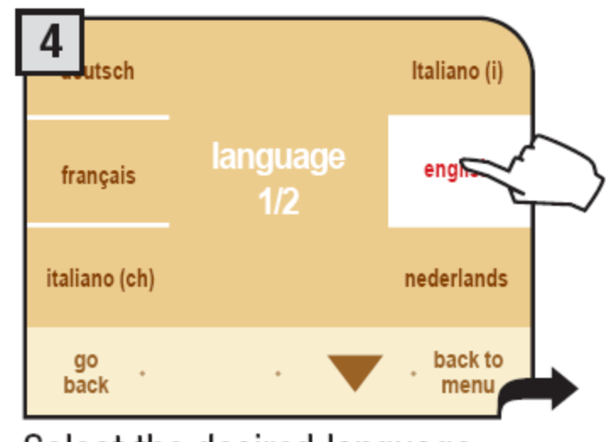

The selection of develop tools or framework

Requirement
Support controls mention in last session.
Platform independent or easily porting
Preferred:
Convenient to use animation /transition effect in controls (to implement IPHONE like style)

Candidates
MFC/WINDOWS API
Platform dependent Hard to implement transition effect.
wxWidgets
Cross platform UI framework with rich functions, build and run on POCKET PC emulator, failed to build on evaluation board SDK, but with greatly opportunity to solve it.
SDL
Cross platform graphic library, can build and run on POCKET PC emulator, but failed to run on evaluation board.
GAPI
A lightweight set of functions to provide the game developer access to the screen and keyboard of a Windows CE device, GAPI contains a handful of functions that provide access to the display’s frame buffer.
PocketHAL
Is an open source C++ library for your Pocket PC and Smartphone hardware. it as a efficient alternative to GAPI. There many simple 2D/3D games on Pocket PC are based on this library.
http://www.droneship.com/pockethal/index.html
PocketFrog
PocketFrog is an open source game library on the Pocket PC platform. It provides some graphics 'primitives' such as line & rectangle functions together with PocketPC button & screen tap handling. It uses GAPI or PocketHal as underline library.
http://pocketfrog.sourceforge.net/index.htm
A rotating bitmap example, run in 28 fps

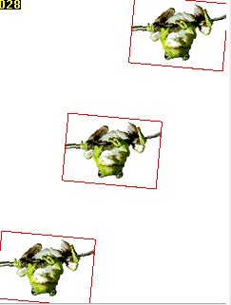

OPENGL ES
It’s a simplified OPENGL subset for embedded system; already have commercial products on most popular platform, most of them needs hardware accelerator support. We have tried the Vincent Mobile 3D Rendering library, which is an open source OPENGL ES implement on WINCE. We have run some demo examples on the evaluated board, but the result do not meet our expectation, the examples run below 10 fps, unable to achieve fluent transition effect.
Possible reasons for low fps:
The library is a pure software implement and using fixed point rather than floating point. And it is a open source implement, would other commercial product be better?
We don’t have many experiments on OPENGL, so there may be some methods we don’t know which can solve the problem.

An example displays a moving bitmap with a background, less than 1 fps.



A demo of showing spheres in different point of view
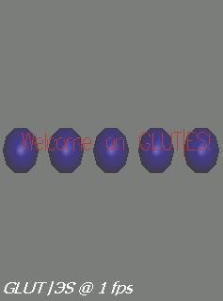

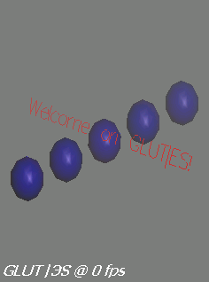
A rotating cube
Average 8 fps


EDGELIB
Is a multi-platform game engine for mobile devices, offers a 2D and 3D graphics, the 3D rendering can used both OpenGL ES or it’s own software 3D library.
3D animate example used EDGELIB’s own 3D render library got 26 fps; the same example used rasteroid(an other software OpenGL ES library) can only get 2 fps.
http://www.edgelib.com/
License fee:
EDGELIB Lite(2D) | $150 (order) | $150
EDGELIB Full(3D) | $950 (order) | $650 (order)

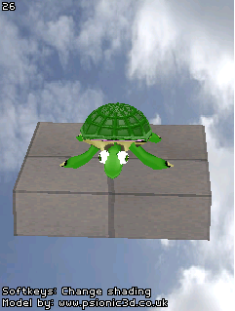

Gapidraw
A commercial library used Directdraw compatible instructions, can render 2D animate in 30 fps.
The price for a GapiDraw binary license is $995
The price for a GapiDraw source code license is $3.495
http://www.gapidraw.com/
A animate example, run in 30 fps
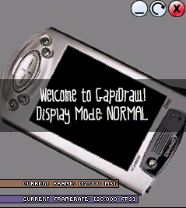
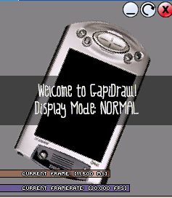
FTouchSL
A application to allows scrolling contents of windows in most of applications (Outlook, File explorer, MS Word, Notes, Contacts etc.) without touching scrollbars! http://www.ftouchsl.com/
SCLPC++
unique Cube Launcher coded in C++ and using the EdgeLib framework library and FTouchSL
, gives a HTC Touch interface to non Touch WinCE phones, there is another similar application uses FLASH LIFE to
http://www.1800pocketpc.com/tag/user-interface
http://forum.xda-developers.com/showthread.php?t=358102
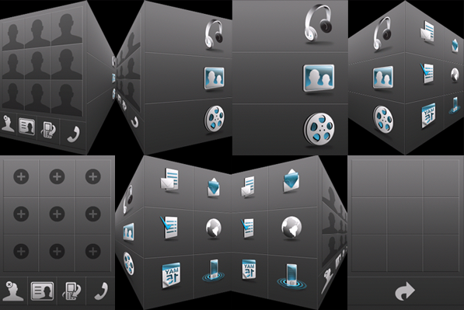

Conclusion:

Name | functions | 2D | 3D | Performance | Price
PocketFrog | Weak | No | No | Medium+ | Open source
DirectDraw | ? | ? | No | ? | Free
Direct3D | ? |  | Yes | ? | Free
OPENGL ES | Powerful | Yes | Yes | low | Open source
Gapidraw | Weak | Yes | No | high | Need
EDGELIB | Powerful | Yes | Yes | high | Need

Conclusion:
The high performance of Gapidraw and EDGELIB provide the possibility of achieving iPhone style transient effect on candidate platform. SCLPC++ is a successful story to prove this.
The FTouchSL can implement most of iPhone’s single touch gestures. The UI application can develop based on these libraries or applications, or we need more time and resource to develop our own graphic and gesture engine.
However efforts need to take to develop a flexible widgets library, which the underline graphic render can be freely substituted by other implement, e.g. PocketFrog
,DIRECTDRAW ,and OPENGL ES.

